Ravan Muradzada
TASK 1
- There are more ways than 2 to determine the mounted disk:
- `lsblk` - it shows all disks; however, we can look at and determine which disk is mounted or not here:
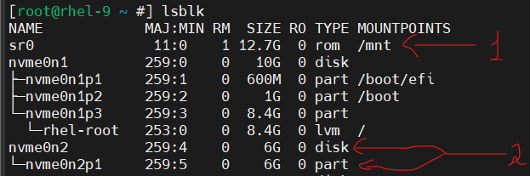
In that example, `sr0` has mounted to `/mnt` directory, we can see it easily. However, there is no mountpoint for `nvme0n2p1` partition of disk.
- `findmnt` - It shows mounted filesystems in the system with a tree view. It shows also options which we can define in /etc/fstab`.
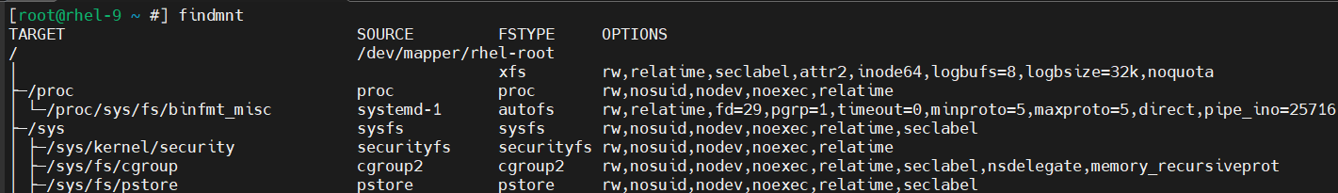
- `df -h` - It also shows mounted file systems. As extra, it gives info about disk space, how much is used or available:
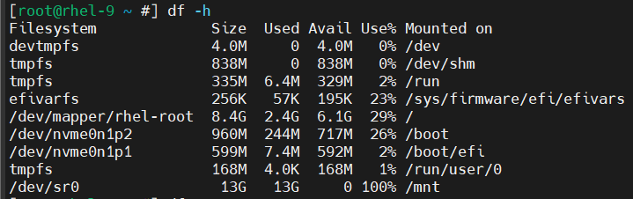
- `mount` (without any option) - I have found another command which also can help us. It is not quite readable but again possible to consider as another command to see mounted file systems:
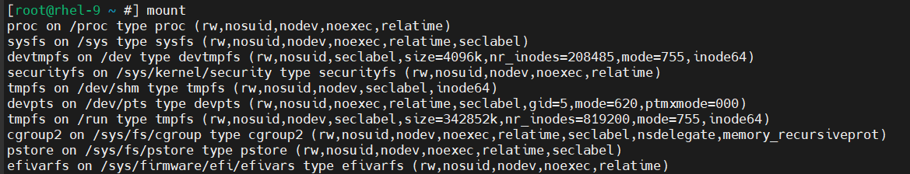
- I have explained them above. Their outputs:
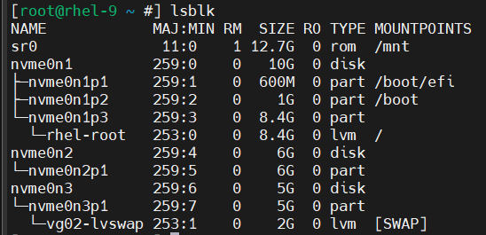
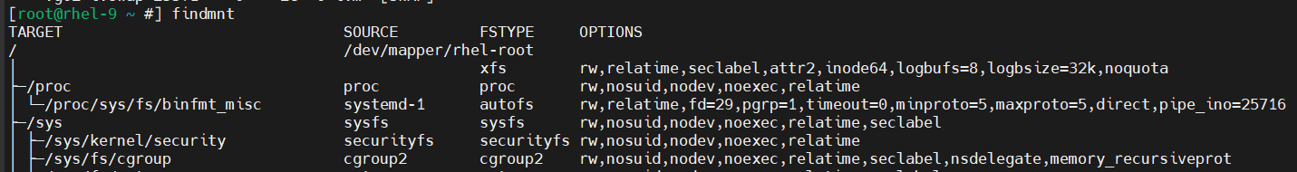
`lsblk` shows all disks and which ones are mounted. `findmnt` shows only mounted disks with an extra info like their mount options as a tree view.
- To add a new disk, we need to go Settings in VMWare Workstation Pro and add new hard disk. We define its volume (5 and 4 GB). I add it as HDD, not SDD. To see them, we need to run `lsblk` command:
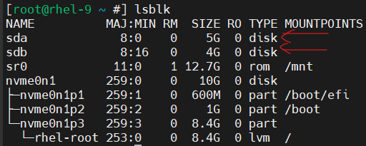
`sda` (5G) and `sdb` (4G) are new added disks.
- First, we need to create a partition. Let’s use `fdisk` (MBR) to create a partition:
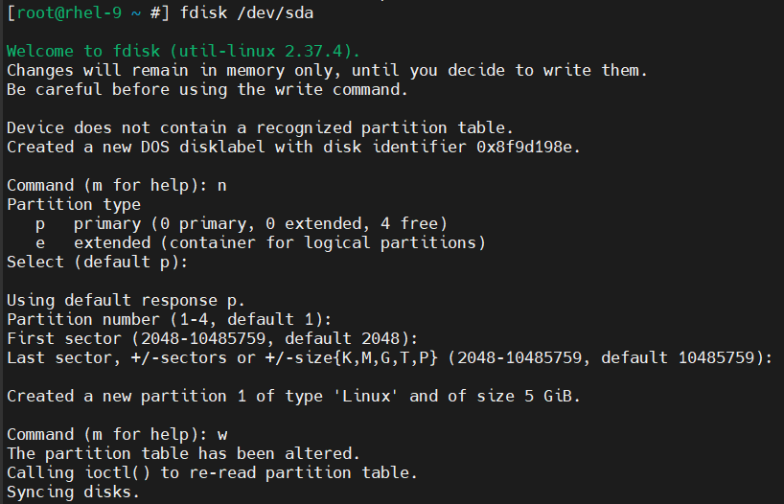
As you can see, I have created one partition and give it full disk space. We can check the newly created partition by just running `lsblk` command.
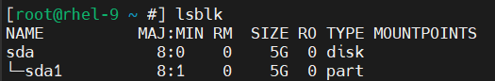
Then we need to create PV for our partition, and then VG. The command to create VG is `vgcreate` and this also creates PV for us, so we do not need to create PV manually:
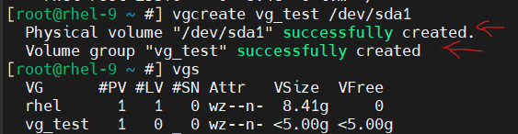
As you can see above, by running `vgs` (`vgdisplay` for more info) command, we can see all `VG`s available in the system and `vg_test` is here.
If we run `pvs` (`pvdisplay` for more info), we will also see PVs available in the system:
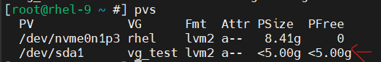
- We have a command `lvcreate` to create logical volumes:
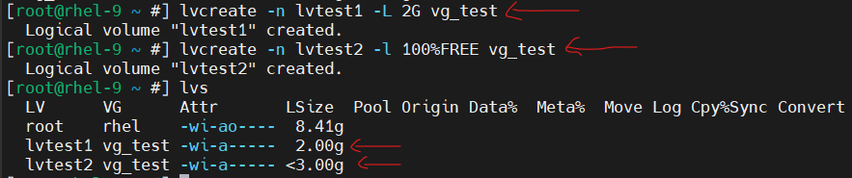
I have used `-L` to create the first logical volume. With `-L` we define exact volumes like `2G`, `100G` or `500M`, etc.
However, I have decided not to write `-L 3G` for the second logical volume, because it would not work. Why? Because LVs always take more space than we specify for them to store metadata.
JUST EXAMPLE: IF WE SPECIFY 6 GB FOR LV, IT TAKES 6,01 GB TO STORE METADATA (ITS UUID, VG IT BELONGS TO AND MORE)
In that case, we either need to write something like `-L 2.99G` or there is a better way which is using `-l 100%FREE`. `-l` is used for that kind of approximate cases. `-l 100%FREE` gives all free space available in the VG to our new LV.

If we use `lsblk` now, we will see our logical volumes:
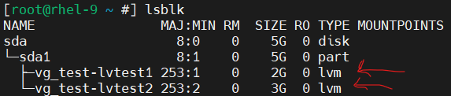
- Our commands to create ext4 and xfs filesystems are `mkfs.ext4` and `mkfs.xfs`.
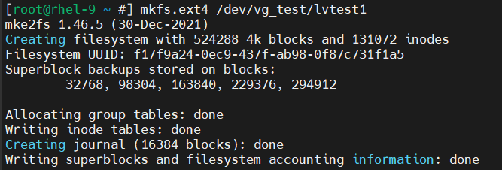
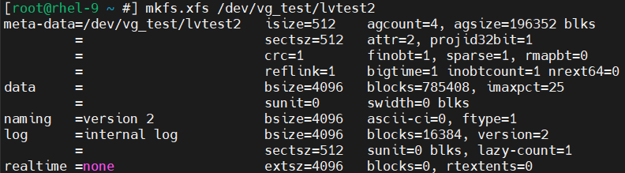

- I have used `mkdir` command to create directories and `touch` for files:
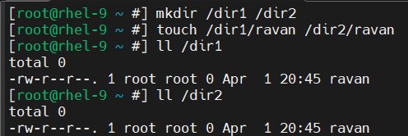
- There are two mount cases: temporary and permanent. To mount a disk temporarily, we just need to run `mount /dev/<DISK_NAME> /<MOUNTPOINT>`.
However, if we need to mount it permanently, we need to add it to `/etc/fstab` file. Let’s mount our disks permanently to `/dir1` and `/dir2` directories.
First, we need to open `/etc/fstab` and add these lines to end of the file:
You may ask what the first UUIDs I wrote were? They are just UUIDs for logical volumes, we can use either logical volume paths or their UUIDs here. That is preferable to use UUID. I have used `blkid` command to find their UUIDs:
The second column specifies the directory where we mount our disk to. The third column is for filesystem type. The fourth column is for mount options; we prefer to write `defaults`. The fifth column determines whether we can take backup of the data on the disk or not. The last column represents the filesystem check at the boot.

After writing them to `/etc/fstab` files, we can restart the system, and the changes will have been applied. Or we have another method, we can just run this command to make changes applied:
- In the folder where I have mounted a disk with `ext4`, a new directory is created inside it:
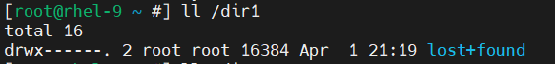
However, the second directory where I have mounted a disk with `xfs`, there is nothing:
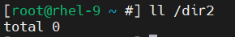

However, when we unmount and remove the lines from `/etc/fstab` and reboot the system, we will see the old contents (ravan file) in the directories, nothing like `lost+found` anymore.

Let’s first determine what is `lost+found` directory. That is not about our case. It is always created when we mount a disk if our filesystem is `ext4`. Regardless of anything, it is just a part of the ext4 filesystem initialization itself. It is created by the fsck utility.
Now the main problem: Where were our files gone? Are they deleted?
Answer: In that kind of case the files under the directory are not deleted, they become hidden. The previous data (my ravan file) is stored on the root filesystem - the same disk that holds our entire OS. When we unmount the disks, we will see `ravan` file in both directories again.
- We use `touch` command to create files: 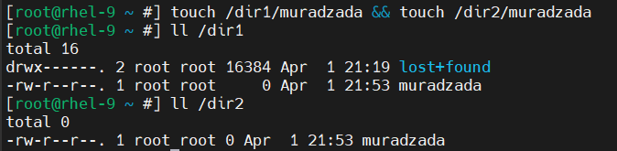
- I have ‘fdisk` command to divide a disk to two partitions:
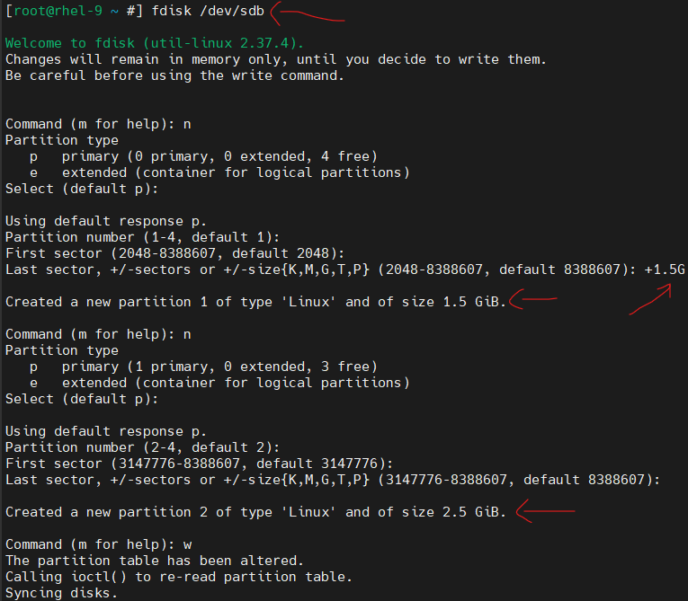
The size of the first partition is 1.5G. The size of the second partition is 2.5G.
Let’s check it with `lsblk` command: 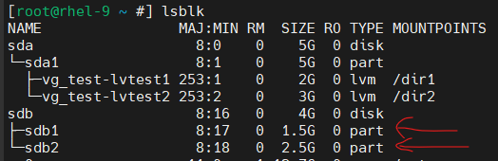
We can see our new partitions from the second disk.
- BTW, the size of the first partition is 1.5G.
We need to use `vgextend <VG_NAME> <PARTITION_NAME>` to extend our existing VG:
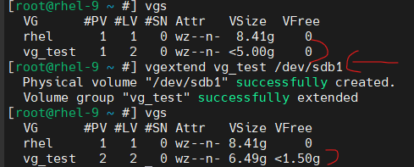
As you can see, the size of `vg_test` has increased.
- We need to use `-s` option to set physical extend. Full command: `vgcreate -s 16 vg_test2 /dev/sdb2`:
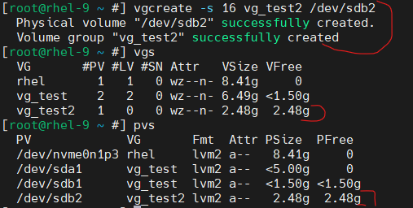
We can check with `vgs` whether the VG is created successfully or not. `pvs` command also shows that PV is created automatically when we run `vgcreate`.
If we want to see Physical Extend in our VG, we need to run `vgdisplay` command:
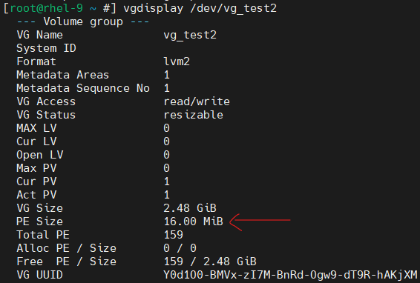
As you can see, it is really 16!

If we want to create a new logical volume named `lvtest2`, we need to use `lvcreate` command. I prefer to use `100%FREE`, because there is no limitation in task description.
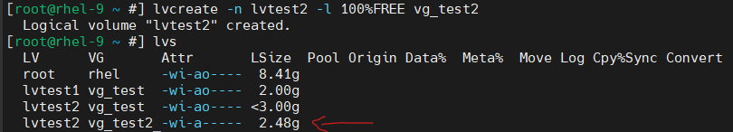

Before mounting a disk to a directory, we need to create a filesystem on it. In our case, I prefer `xfs` filesystem and use `mkfs.xfs` command:
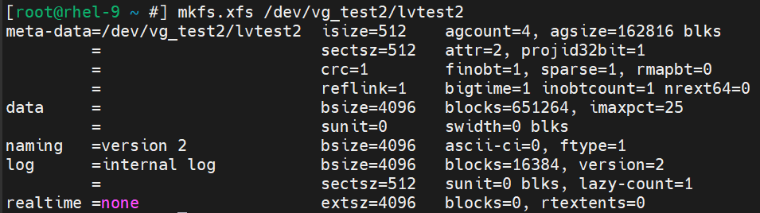

If we mount a disk to a directory permanently, we need to add a line about it to `/etc/fstab` file and run some specific commands. I have talked about it above.
However, let’s do it again and use `blkid`, `cut` commands and redirections (it is asked in the next task).

First, let’s create a directory `/oradata` as specified in the task:

Then we can use that command to add a new line to `/etc/fstab`:

If I print the last line of `/etc/fstab`:
`cut` command is used to extract specific parts of each line from a file or input.
`blkid` command helps us to get information about UUID of the partition or logical volume and filesystem.
As a redirection, I used `>>`, not `>`. Because I do not need to overwrite. I want to append.
We need to reboot, or write `systemctl daemon-reload && mount -a` command to make changes applied.

- I have used `blkid`, `cut` commands and redirection to add a line to `/etc/fstab` file in the previous task. If we add a line to `/etc/fstab` about a disk and mountpoint successfully, and reboot the system, that means the disks are successfully mounted. We can check it:
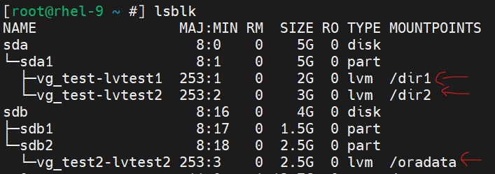
As you can see, these three directories are mountpoints for my disks (LVs).

Rebooting is the best way to check whether the disks or logical volumes are successfully mounted or not. If there is no problem in the booting, that refers we have done it right!

- As I mentioned above, we need to add the specific line to `/etc/fstab` file to mount disks permanently.
The syntax of fstab is like that:
Partition or logical volume path OR their UUID + mountpoint (directory) + Filesystem + mount options (I prefer defaults) + value to allow or deny backup + value to allow or deny filesystem check in the boot.

Task 2
- Currently, there is no swap memory in my VM. So it is the first swap memory I will add.
Let’s create VG from existing partition:
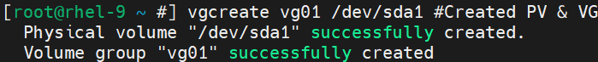
Let’s create LV (I gave full VG space, because there is no limitation in the task):
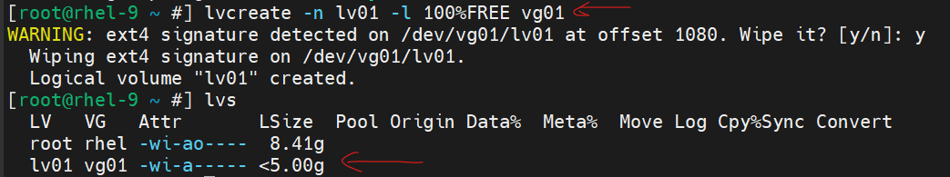

Then we need to use `mkswap` command to write its filesystem:
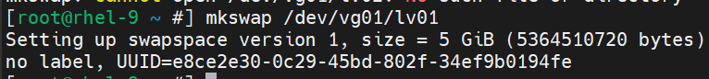
- First, let’s take UUID for the LV:
Then add this line to `/etc/fstab`:

If we want to check whether the swap memory works successfully or not, we use `free -mh` command:
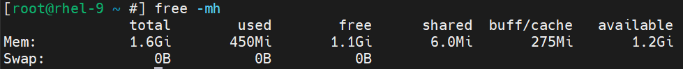
As you can see, there is no swap memory yet. We will solve it in the next tasks.
- As I mentioned in the previous task, we need to use `free -mh` command to display both RAM and SWAP memories.

If we want to ‘activate’ the swap memory, we need to either reboot the system or run these commands:
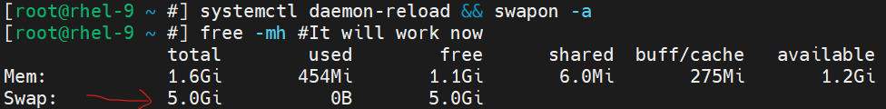

- /etc/fstab is a static and basic config file where we write manually. It is basically a file to tell the system about permanent mounts. The mounts will work even after the reboot process.
/etc/mtab is a dynamic file that our system handles automatically. We never touch it. It is automatically updated whenever we mount or unmount something.
On RHEL 9, /etc/mtab is soft link for to /proc/mounts.
- It is mounting options which we can use. We can write `ro` which means read only. `noauto` is used skip boot mounting. `_netdev` means not to mount if there is no network.
- As I mentioned above, it is `_netdev`.
- I can change it to this:
Then reboot the system to check whether everything is ok or not.
When I try to create any file inside `/dir` directory, it is impossible:
If there is any executable file beforehand, we cannot execute it, because there is ‘noexec` too.
- `noexec` does not allow any binaries or scripts from being executed from that mounted filesystem.
- A partition table is a data structure stored on the disk which shows how our disk is divided and stores some data like partition start and end point in the memory. It is in the beginning of the disk where is called `First Sector`. In MBR, we can create 4 primary partitions. OR we can create 3 primary and one extended partition which includes theoretically unlimited logical partitions.
- There are two main limits which are solved in GPT. The first is disk size, so MBR lets us divide the disks with max size 2 TB. In GPT, it is up to 8 ZB. The second is partition count. MBR lets max 4 primary or 3 primary one extended partition. GPT it is 128.
- When we run `df -h`:
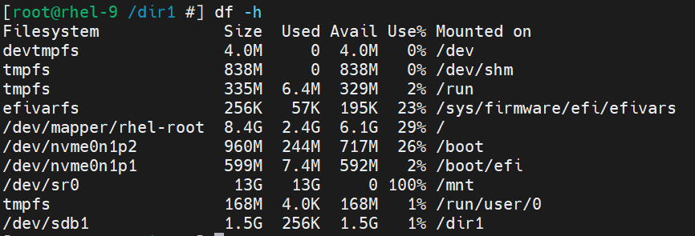
`/boot` cannot be on LV, because GRUB (which is bootloader) runs before LVM is initialized. Thus, GRUB does not have any info about LVM. The others can use LV, because they already know about LVM while booting.

Task 3
- To create a new mountpoint:
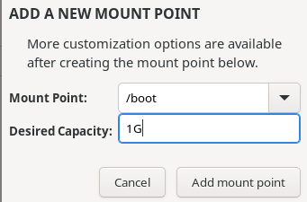

To create a new vg (vgproject):
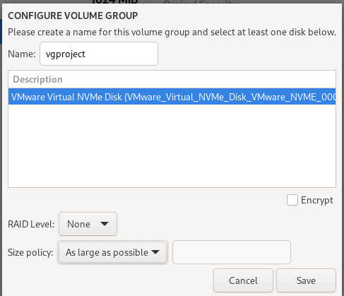

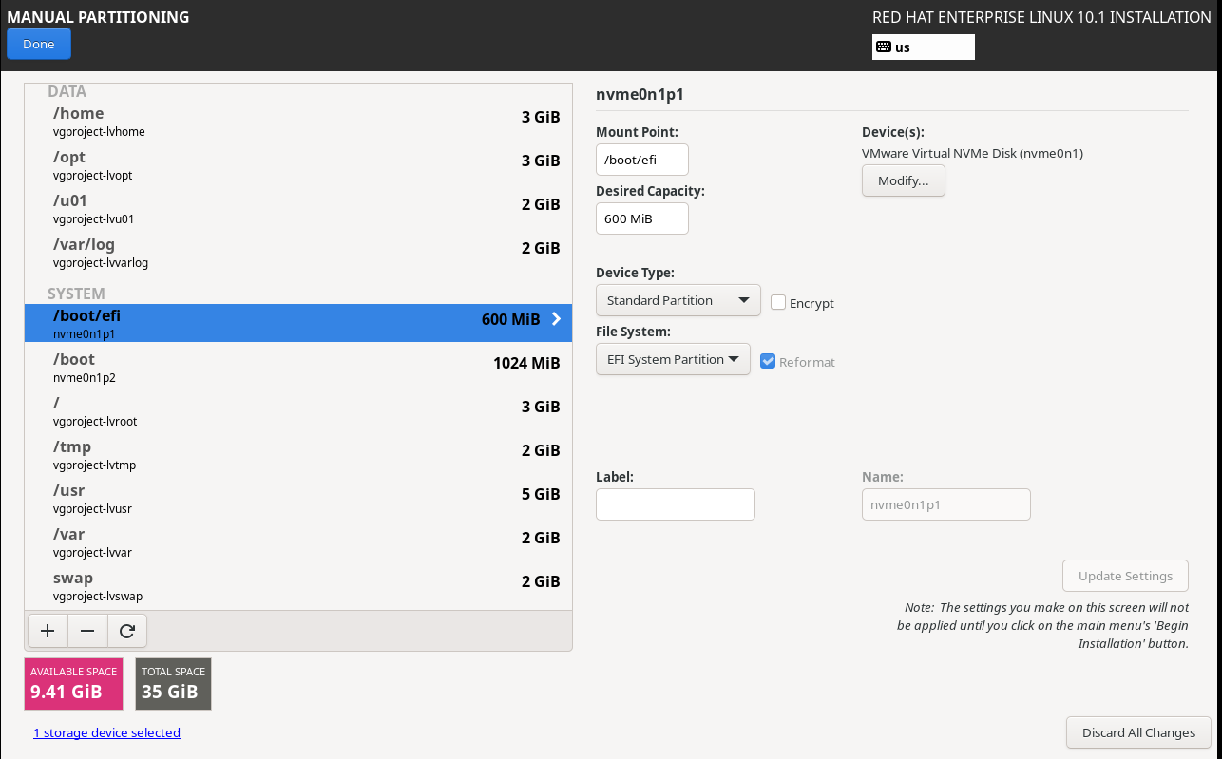
As you see, I give 5GB to /usr.

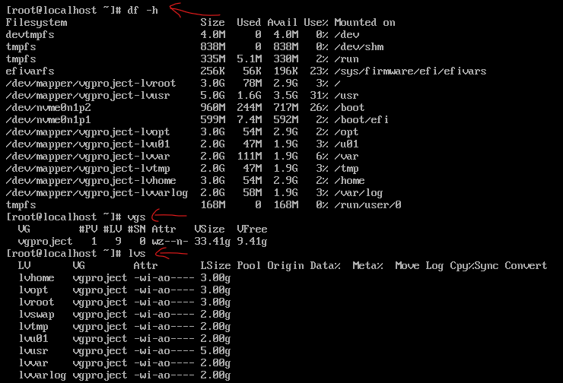
To verify swap is active run:
